SDM COLLEGE OF ENGINEERING AND TECHNOLOGY, Dharwad-580002
(An autonomous institution affiliated to Visvesvaraya Technological University, Belgaum-590018)

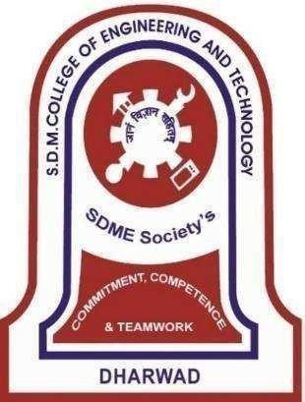

Department of Information Science and Engineering
7th SEMESTER B.E ACADEMIC YEAR: 2025-26 MAJOR PROJECT PHASE - I

COURSE CODE: 22UISL702
“Eye Tracking – Based Password Authentication for Enhanced Security”

Under The Guidance Of

Dr. Anita Dixit
Submitted by,
ANDANAGOUDA S POLICEPATIL 2SD22IS004
DARSHAN SARAVARI 2SD22IS013
SRUJAN ARAVALLI 2SD22IS053
H. M. JADESH 2SD23IS402

SDM College of Engineering & Technology, Dharwad-580002

(An autonomous Institution affiliated to Visvesvaraya Technological University, Belagavi – 590018)
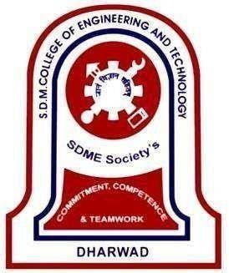

Department of Information Science and Engineering

CERTIFICATE

This is to certify that the Major Project Phase - I entitled "Eye Tracking – Based Password Authentication for Enhanced Security" is a bona fide work carried out by Mr. Andanagouda S Policepatil, Mr. Darshan Saravari, Mr. Srujan Aravalli, Mr. H. M. Jadesh bearing USN. 2SD22IS004, 2SD22IS013, 2SD22IS053, 2SD23IS402 respectively in successfully completing the project for VII Semester B. E. Degree in Information Science and Engineering of S. D. M. College of Engineering, Autonomous Institution under Visvesvaraya Technological University, Belgaum during the year 2025-2026. It is certified that all necessary suggestion indicated for internal assessment have been incorporated. The project work has been approved as it has successfully satisfied the academic requirements.

Dr. Anita Dixit | Dr. Varsha Jadhav | Dr. Jagadeesh Pujari | Dr. Ramesh. L. Chakrasali
Project Guide | Project Co-Ordinator | HOD ISE | Principal

 | Examiner 1 | Examiner II
Signature with date
Name

